Content 43

Predefined Macros & Other Pre-processor Directives: C

Let's start **preprocessor directives** as we have already covered #define and #include in the previous tutorial. In this, we will move forward to a few others.

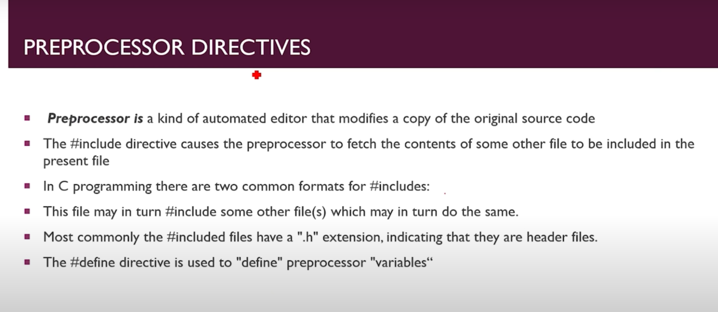

#### #undef:

As can be guessed by the name, it is used to undefine a macro to eliminate its definition.

**Example:**

#define E 1111

#undef E

E is not defined for any value after using #undef, so it holds no value in the above example.

#### #ifdef:

It is used to check whether a macro is defined or not. If it is defined, then it executes the code.

**Example:**

#ifdef M

//execute code if true i.e., the macro is defined

#### #ifndef:

It works exactly the opposite of ifdef. Meaning that it executes the code if the macro is undefined.

**Example:**

#ifdef M

//execute code if true i.e., the macro is defined

#### #if:

It checks whether the given condition is true or not. If true, then it executes the code.

**Example:**

#if condition

// execute code if true i.e. condition satisfied

#### #else:

If the condition of ‘if’ is false, then the else is executed.

**Example:**

#if condition

// execute code if true else pass it to #else

#else

// execute code if “if condition” is false

#### #elif:

It is used to insert more conditions between if and else. If the “if statement” is true, then elif won’t be checked.

**Example:**

#if condition

// execute code if true else pass it to #elif

#elif expression

// execute code if true else pass it to #else

#else

//else code

#### #pragma:

Pragma is used to issue some **special commands** to compiler.

Let's discuss some **pre-defined macros** now. A pre-defined macro is a macro that has already been defined or understood by C preprocessor and does not need a definition.

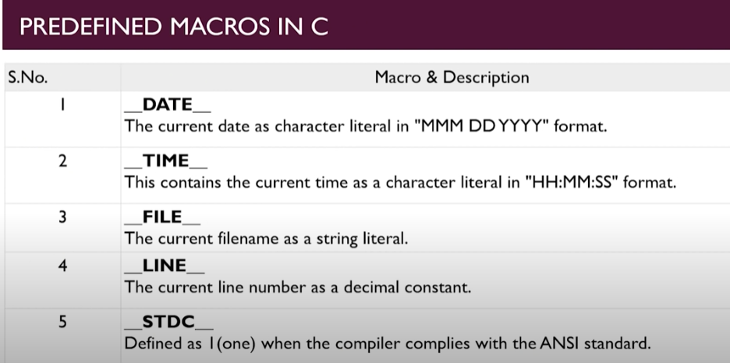

**Code for Predefind Macros in C :**

#include<stdio.h>

#include<stdlib.h>

int main(int argc, char const *argv[])

{

    printf("Today's Date is: %s \n",__DATE__);

    printf("Now Time is: %s \n",__TIME__);

    printf("This file Name is: %s \n",__FILE__);

    printf("Line number is: %d \n",__LINE__);

    printf("ANSI is USed?: %d \n",__STDC__);

    return 0;

}

**Output:**

Today's Date is: Mar 25 2021

Now Time is: 22:34:13

This file Name is: MacrosCnt24.c

Line number is: 8

ANSI is USed?: 1